**HEALTHY EATING OPTIONS FOR KIDS**

**Snacks and Drinks**

**Try this:**

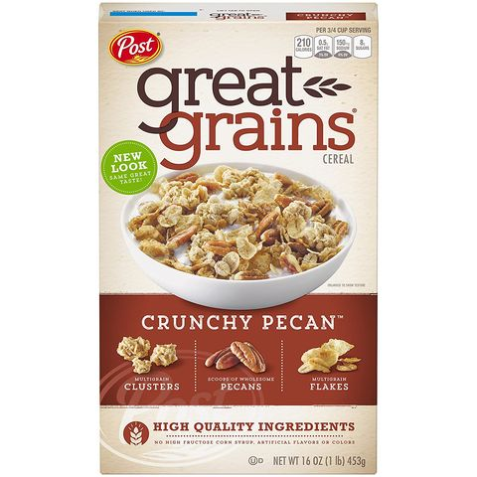

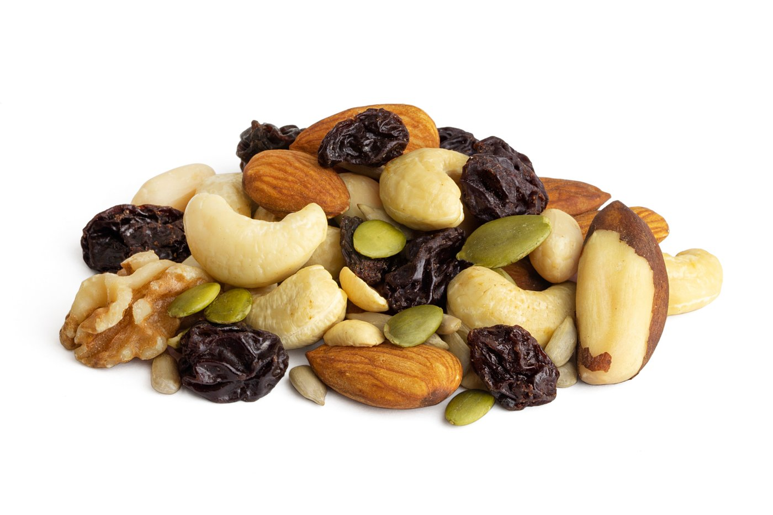

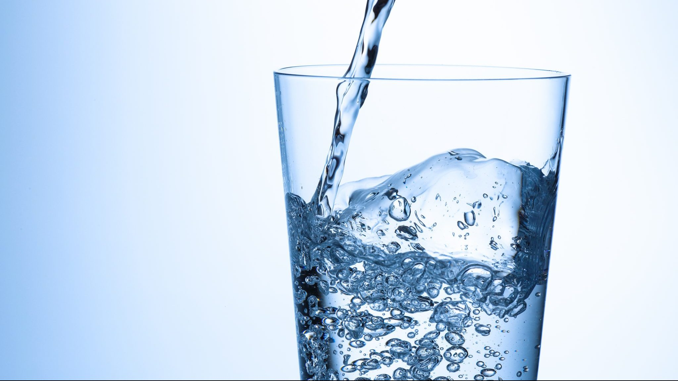

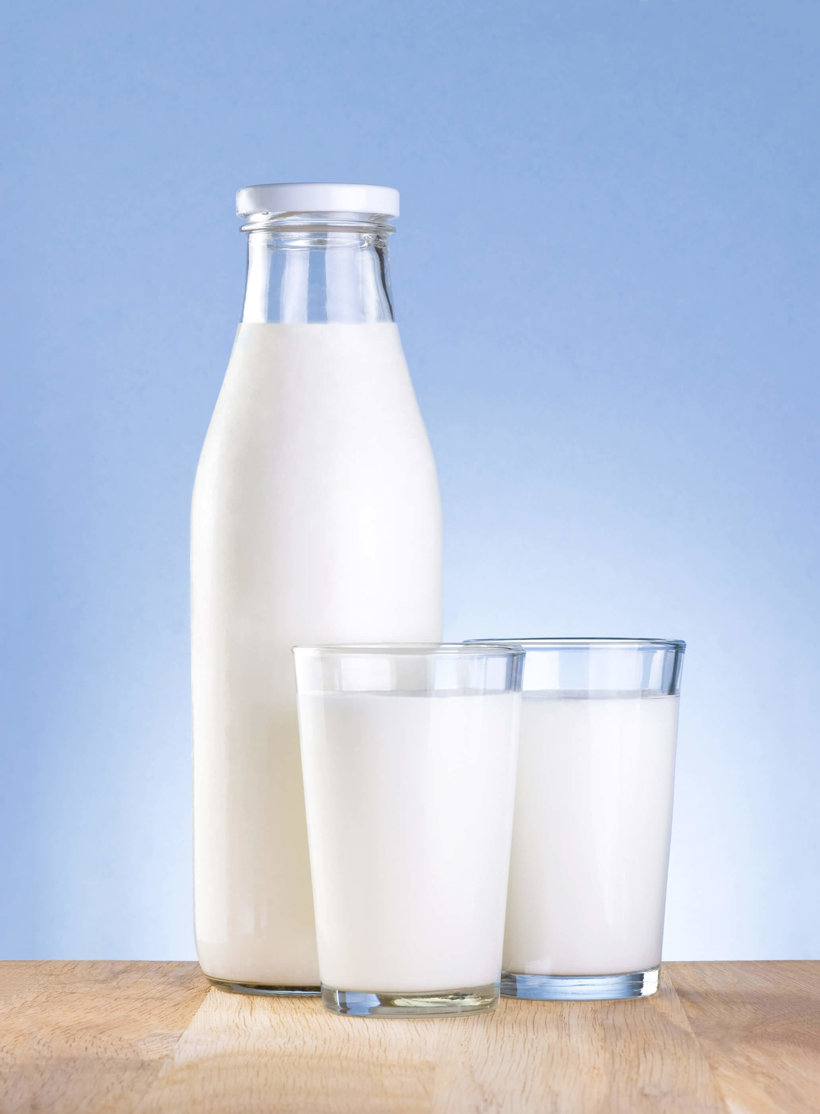

**Don’t try this:**

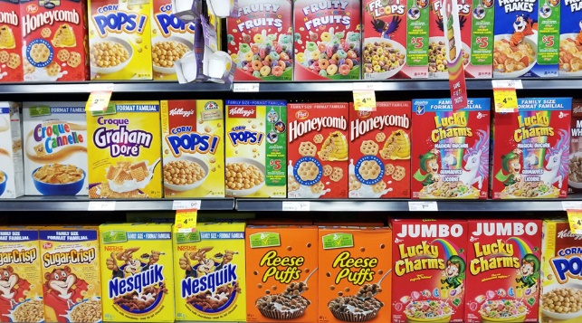

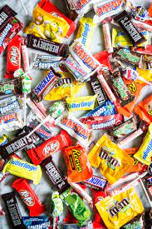

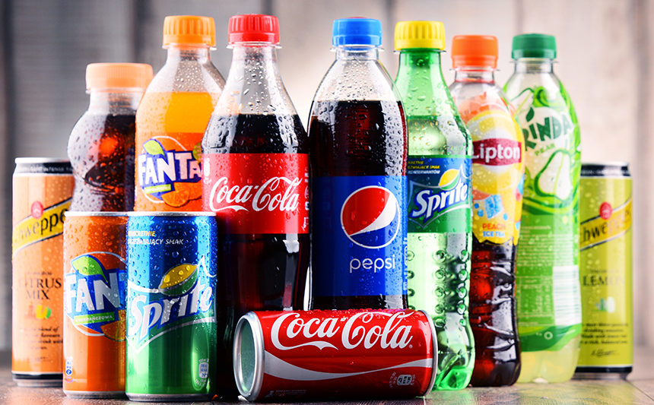

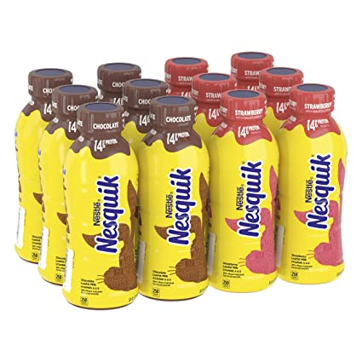

**HEALTHY EATING OPTIONS FOR KIDS**

|  |  |
| --- | --- |
| **Snacks** | |
| **Instead of:** | **Choose:** |
| Generic Processed Cereal | Whole Grain Breakfast Cereal ([1]) |
| Artificially Yogurt | Plain Yogurt w/ Fresh Fruit ([2]) |
| Pre-flavored Popcorn | Air-Popped Popcorn w/ Butter and Grated Parmesan ([3]) |
| Peanut Butter and Crackers | Celery w/ Peanut Butter and raisins* |
| Candy | Nuts / Trail Mix* ([4]) |
| Flavored Packet Oatmeal | Rolled Oats w/ cinnamon and diced apples ([5]) |
| Hot Pockets | Veggie Pita Pocket ([6]) |
| Chocolate Chip Cookies | Banana Oat Cookies ([7]) |

*Includes nut allergens

References for recipes and amazon purchase links can be found on the following document.

|  |  |
| --- | --- |
| **Drinks** | |
| **Instead of:** | **Choose:** |
| Soda and other artificially sweetened beverages (such as sweetened milks like chocolate and strawberry milk) | Water / Lightly Flavored Water / Plain Milk Variants (try to go with low-fat) |
| Juice | Coconut water |
| Caffeinated Beverages | Certain Fresh Fruit & Vegetable Smoothies (Kale and Pineapple, Spinach and Blueberries, Peach and Cauliflower, Strawberries and Beets, etc.) |
| Certain Herbal Teas (namely lemongrass, mint, rooibos, and chamomile) |

* According to the Dietary Guidelines for Americans and MyPlate, everyone should have half their plate consist of fruits and veggies, then add a high protein food along with grains (half of which being whole grains) to make up the other half of your plate.

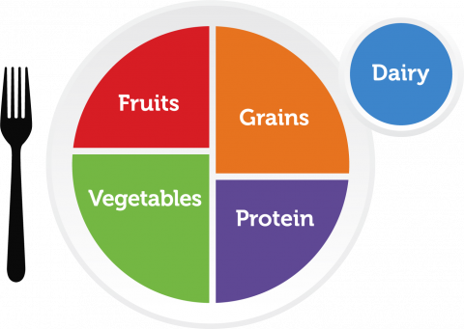

* According to EatRight.org, you should encourage your child to drink 8-12 cups of water a day.
* Accompany your child at least three days per week while they take a 30-60 min. break from video games or watching tv to go outside and walk or bike around the neighborhood / play games in the backyard.

1. References

   <https://www.amazon.com/gp/product/B0014CU7T2?tag=goodhousekeeping_auto-append-20&linkCode=ogi>
2. <https://www.amazon.com/Stonyfield-Organic-Whole-Plain-Yogurt/dp/B00108EPCU/ref=zg_bs_13769138011_2?_encoding=UTF8&psc=1&refRID=31ZSBNXGAVZB4GWNJ842>
3. <https://www.amazon.com/Dutchmans-Popcorn-Fashioned-Microwaveable-Stovetop/dp/B07D4QQR2B/ref=sr_1_17?dchild=1&keywords=air+popped+popcorn&qid=1617115212&s=grocery&sr=1-17>
4. <https://www.amazon.com/Power-Up-Natural-Antioxidant-Variety/dp/B07JQ1NF3Z/ref=sr_1_25?dchild=1&keywords=trail+mix&qid=1617116632&s=grocery&sr=1-25>
5. <https://www.amazon.com/Bobs-Red-Mill-Resealable-Organic/dp/B07ZQNS2FY/ref=sr_1_5?dchild=1&keywords=rolled+oats&qid=1617116845&s=grocery&sr=1-5>
6. <https://www.foodnetwork.com/recipes/food-network-kitchen/veggie-stack-pita-pockets-recipe-1927965>
7. <https://kirbiecravings.com/2-ingredient-banana-oatmeal-cookies/>